Operations Management Module
Student’s name
Course name
Professor’s name
Date

Operations Management Module
It is the desire of every competitive company to ensure that its operations that include production, distribution, and marketing are highly efficient and effective. This would enable the company to operate economically while producing quality products for its customers ( Heizer, 2016). The employees play an important role in fulfilling this objective. At our operations department, we are keen at ensuring that newly employed graduates understand the impact of product design on our operations and supply chain strategy. This would enable them to undertake their roles more effectively. Noting that the majority of new graduates hired by the company studied marketing or engineering degrees, we developed a manual that would be brief and easy to understand.
Product design process
Product design is defined as the process of deciding on the features and characteristics of a new product. A company should choose a product that is unique so as to beat the competition. Production of similar goods in an industry leads to more competition. New entrants would face unfair competition from already established firms and thus might not survive. The aim of the product design process is the establishment of a unique and highly marketable product that fulfils some customer need (Ulrich, 2013). It is worth noting that product design process determines product quality, customer satisfaction, and product cost. Product design is connected to the production process. The production process should be kept low in order to ensure that the revenue generated from selling the product covers the cost of production.
Improving Operations efficiency and effectiveness
The improvement of operational efficiency in all company activities is a matter of concern to us. Continuous improvement is a quality management technique that proposes continuous review and implementation of strategies that makes the company be at a better place today than it was yesterday (Hutchins, 2016). This can be achieved through process improvement which entails the optimization of processes through automation and integration. This process is instrumental in ensuring that production costs are kept low and customer needs are met. Operational efficiency can also be achieved through restructuring the company in order to have the lower operational costs. Restructuring of man power also ensures that workers are used more optimally. Similar company operations are also matched to together to achieve.
The effectiveness and efficiency of the company’s operations and value chain should be continuously assessed. This allows the company to identify loop holes that should be corrected. The assessment should include organizational analysis aimed at reducing complexity in structures and processes. Complex organizational structures complicates the chain of command making employees unsure of whom to report to (Christopher, 2016). Company operations run more smoothly when the organizational structure is simple and clear. Team leaders provide subordinates with guidance whenever they need and thus limiting the occurrence of losses. Employees should also be motivated through financial and non-financial rewards to boost their performance.
Example
The advancement of technology has led to development of operations management tools that have made processes simpler. There are many operations management tools in the market that can used in different departments. The quick books software used in accounting makes accounting helps in book keeping operations. The NetSuite system is another example of a tool used in operations management (Rolling, 2016). It is an enterprise resource planning tool that automates financial functions that include accounting, billing, invoicing, and financial planning. It also facilitates tracking of inventories and making of orders. The systems have security features such as passwords that restricts use by unauthorized users. This is aimed at reducing cases of fraud within the organization.
Components of the distribution or logistics operation
Logistics is the flow of goods from one stage or point to another majorly from raw material to final products made available to customers. The process of converting a raw material to final product involves a series of processes that includes transportation. Companies should therefore ensure that logistics operations are effective (Rushton, Croucher & Baker, 2014).This would lower logistics costs that resultantly lowers the cost of production. The logistics operations consist of a number of components namely; inventory management, transportation, storage and handling of materials, packaging, demand forecasting, production planning, facility location, purchasing, and customer service. The following is a diagrammatic representation of the components of logistics operations at our company.

Components of logistics operations

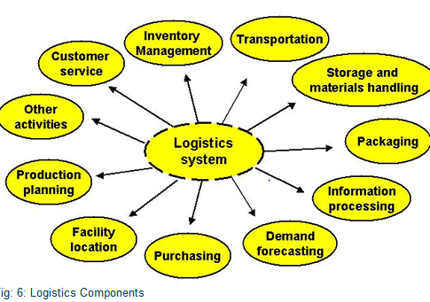

The adoption of technology in more areas of our company is listed as a strategic planning goal of our company. The upgrade of logistics systems through the introduction of robots that would transport products from one stage of production to another is work in progress. This would lead to reduction of human labor in the company and resultant decline in the cost of production. Reduced cost of production would enable the company achieve higher profits good and increase shareholders’ wealth.

References
Christopher, M. (2016). Logistics & supply chain management. Pearson UK.
Heizer, J. (2016). Operations Management, 11/e. Pearson Education India.
Hutchins, D. (2016). Hoshin Kanri: the strategic approach to continuous improvement. Routledge.
Rolling, T. (2016). Using Netsuite in Business Curriculum. Journal of Higher Education Theory and Practice, 16(5), 42.
Rushton, A., Croucher, P., & Baker, P. (2014). The handbook of logistics and distribution management: Understanding the supply chain. Kogan Page Publishers.
Ulrich, K. T. (2013). Product design and development. Tata McGraw-Hill Education.

